Newport High Scholl junior academy 2016 – 2017

Newport High school junior academy won the WRU Trophy Cup this season.

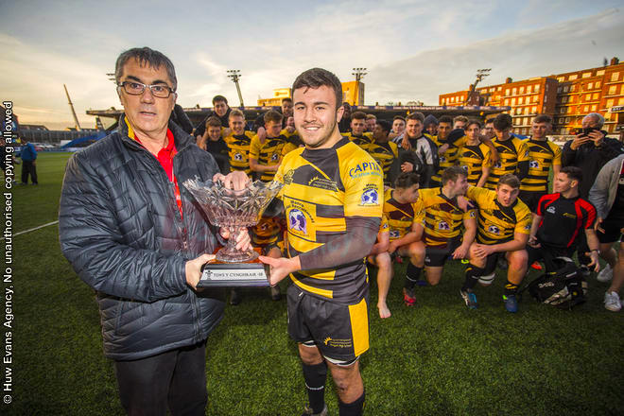

This achievement was great reward for the effort and dedication shown by the squad members this season.

The success on the field has seen 16 of our squad get recognition by being selected for the Dragons regional U18 team. They are: -

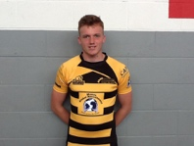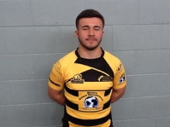
Calum Corey James Joshua William Harri
Hague Howell McCarthy Lewis Fishlock Harding

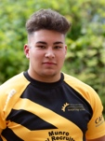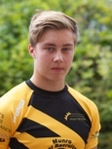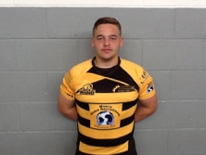

Josh Lennon Matthew Sam Thomas Jamie
Reynolds Greggains Williams Dinsdale Hoppe Luckett

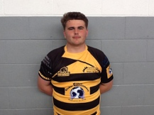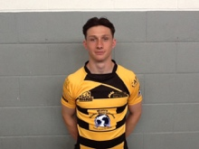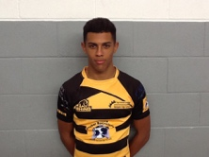

Luke Reagon Rio Dan
Yendle Mahoney Dyer Babos

The high performances of our academy players resulted in big wins for the Dragons U18 in the Regional age grade tournament held in January and February. They made the regional final where they faced the Ospreys U18 and lost in a very close, hard fought game. So close in fact, that it was only decided in the dying seconds.

The performances in the regional competition has meant that six members of our squad have been selected to represent Wales U18 this season. These are: -

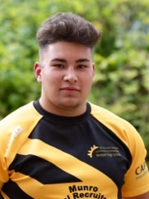
Josh Corey James Lennon Thomas Dan
Reynolds Howells McCarthy Greggains Hoppe Babos

I believe all the students and teachers of Newport High School would like to congratulate these boys who have achieved Dragon age grade and Wales U18 recognition this season.

The coaches of the junior academy would also like to congratulate these boys and also the other junior academy squad members for their hard work both on and off the pitch. It is credit to them all that they manage to balance both their academic studies and their rugby commitments and I am sure that such a task would be deemed impossible if not for the support of all the teachers and staff at Newport High School.

The junior academy would like to thank our sponsors for their continued support towards the programme. We hoped you enjoyed the season so far and we would also like to thank Newport friends of rugby, for their support with the use of the facility at Rodney Parade.

Robert Sidoli James Leadbeater
Head Coach Junior academy Assistant Coach junior academy

Gareth Lewis Rhys Thomas
Rugby Development officer Attached Coach

